LISTENING 1

QUESTIONING 2

ENCOURAGING 5

REQUESTING 8

ACTION PLANNING 9

LIVE COACHING DEMO 14

GUIDING PRINCIPLES 17

BREAKOUT ROOMS WITH DEBRIEF 18

WHY COACHING 19

USING ZOOM ANNOTATION 23

DYAD COACHING AND DEBRIEF 24

OTHER 27

# LISTENING

Contributing Trainers: Julie Jones, Lorilee Sweeney

This exercise makes a great icebreaker and listening exercise. Our group currently uses this exercise, but I have given it some further thought to how to make it work virtually.

Currently done in dyads, you would break into your group and share some things about yourself, maybe something different or unique and some general information. After a brief conversation, everyone comes back into the group.  At that time, you would ask   one of the dyad members to introduce their partner to the larger group.

To modify this, you could breakout into groups of four and then pick one person to introduce. Another twist on this, you may or may not tell the groups ahead of time that they will be asked to introduce someone in their group to challenge how well they listened to the others and what they retained.

## Storytelling and Active Listening:

Divide into groups of 4. Inform the group that one person in the group is going to tell a story for 3 mins either about themselves, what happened on the way to work, a funny story etc. (there is usually one good storyteller in every group). The remaining 3 people are going to provide complete space for the person to tell the story without interruption or questions and self select from the following roles. The goal is to focus on Level 1, 2 and 3 as follows:

1 person listens at Level 1 and focuses on the FACTS

1 person listens at Level 2 and listens to discern the other’s FEELINGS and EMOTIONS

1 person listens at Level 3 and listens for the essence of what is being said and listening to understand the other person’s BELIEFS and VALUES

Debrief:

Ask the storyteller what it was like to have the floor without interruption

Each person relays what they heard/discerned and checks out the validity and questions with the storyteller and also talks about the experience of just listening for facts or just listening for values etc.

When actively listening, we need to practice being able to listen at all 3 levels.

# QUESTIONING

Contributing Trainers: Clare Connolly, Cliff Raphael

**Questioning Activity:**

By Clare Connolly

**Creating powerful questions for a volunteer in the group**

After you have shared what makes a powerful question, (open ended, clean and a variety of questions), ask for a volunteer who would be willing to share a coaching situation so the group can practice asking questions.

**The facilitator introduces the activity:**

* “I’m looking for a volunteer who would be willing to take 1-2 minutes to share a situation with the whole group so we can practice making questions.
* The group will be divided into small groups (breakout rooms) and will come up with 3-5 open questions for the person who shared their coaching situation
* The group will then come back together as a large group, and we will share our questions with the coachee. The coachee is asked *not to answer* the questions, but just hear the questions. They will have a few seconds after each question to *think* about their answer (but not share their answer).
* In the break-out room, the person who shared their situation will participate in generating questions but is asked not to answer the questions.
* This activity is not about how the coachee will answer; it’s about practicing asking powerful questions
* Who would like to volunteer and share their situation?”
* If everyone is quiet, I restate that it’s a great chance to hear some powerful questions that will be really helpful for the person being coached, and there is no expectation that they share any answers.
* A volunteer appears. We cheer and thank the person for volunteering and ask them to share their situation with the group.
* Before putting them into breakout rooms, I ask them playfully:

“How many of you have already put on your problem-solving hat and have thought of solutions you want to tell the coachee?” (Hands go up and usually there’s laughter).

I remind them to:

* + - take off their problem-solving hat and
    - Create questions from a curious place
    - The questions are for the coachee, not the coach
    - Be careful of leading questions
    - Focus on open questions

**Put them in breakout rooms for approximately 5 minutes**

* Visit the break-out rooms to see how they are doing and to hear a question or two, answer their questions etc.

**Bring them back from the break-out rooms**

* Bring them back, and have each group ask a question directly to the coachee. Remind the coachee not to answer, but ‘let it land and reflect on the question’
* Remind the group to allow a few seconds of silence while the coachee processes the question

**Facilitator supports success by:**

* Any questions that are closed, we practice changing them to an open question.
* Facilitation asks, mid exercise, this question to the group:
  + What are you noticing after you ask the question? (Even though the coachee is not answering).
* They may state, or facilitator can share: “Notice what happens with these questions in that the coachee shows they are reflecting, perhaps nodding, looking down or sideways, or may say “oh that’s a good question” or similar. We discuss non-verbal cues, and resonance.

**Wrap up:** At the end, facilitator asks what they are learning about powerful questions.

* At the *very* end of the exercise, (especially if you are pausing for a break), ask how many of the coaches are “just waiting for the break to share their ‘perfect solution’ with the coachee”. People may nod, laugh, or put their hand up. Remind them about the importance of holding the coachee as resourceful and capable and allow the coachee to reflect on their great questions and come up with their own solution/next steps.
* Facilitator must keep it safe for the volunteer coachee throughout.

Note: I’ve never **not** had a volunteer, but in case that happens, I have a situation ready in mind that I can share in case I need to be coachee.

## Questioning Exercise

Questioning Exercise (Cliff Raphael)

The question is…?

REQUIRED:

1. Volunteer with a “coaching issue” to be the coachee (the volunteer should be chosen beforehand).
2. Ask participants to use the whiteboard and annotation to type a question they would ask the coachee.
3. Group questions into open-ended or closed questions.
4. Get input from participants on how different questions will impact the forward momentum of the conversation.
5. Have participants reframe the closed questions into open questions.
6. Lead into “What makes a powerful question”? Invite participants to type their response in the chat or use the annotation feature.
7. Breakout for practice on asking curious, powerful questions.
8. De-brief (self-reporting).

# ENCOURAGING

Contributing Trainers: Charlene Mellors, Claudy Pastoor, Chantal Normand

A real life story …

One day I was not able to make a deadline at work.

I expected by Manager to go nuts and berate me for not managing my time very well.

When I told her she said:

“Claudy, there are a lot of competing priorities in our work now a days. What I appreciate about you is even when you can’t make a deadline, you still show ownership and accountability.”

My opinion of my actions and self changed in an instant.

## Encouraging

[Show Slide 1]

ACTIVITY (Note this is a 2-part activity)

Part A

[Ask participants to…]

• Think of someone you would like to acknowledge. Write what you would like to say to them on a

piece of paper.

[Show Slide 2]

[Speak to the following:]

• Encouragement may not always be as overt as you might think. In coaching, we have a constant

presence of the essence of encouragement.

• This means that behind ALL of the coach’s words and actions is an authentic belief that the person

they are coaching is capable and resourceful.

• This takes a high level of self-awareness and development on the coach’s part to know what their

personal filters are and when they are influencing the coaching dialog.

• Every one of the core coaching skills needs to have the essence of encouragement behind it…Even

when you may not agree or fear troubling consequences may ensue.

• If the essence of encouragement is abandoned, forward movement and thinking comes to a halt

and trust is affected.

• As coach, your concerns and judgments need to take a backseat as the coaching process unfolds.

• You will learn how to explore those concerns as an exploration partner as we move forward in this

program.

• Review slide 2 on Praise, Compliment or Acknowledgement and describe the difference between

the three.

• [Show Slide 3] Review slide 3 on Encourage the Person, not Results.

ACTIVITY (Part B):

[In break-out rooms, groups of 4]

• Each participant shares what you wrote. Is it a compliment, praising or acknowledgement?

• Use your learning partners to reframe any compliments/praises to encouraging with

acknowledgement.

[Back in large group]

• Ask participants to share their one or two examples in the chat space

• Ask Participants to recap their learning around ENCOURAGING: “What is your take-away?”

▪ Encouragement starts with listening.

▪ Everyone responds differently to different types of encouragement.

▪ It is important to have the essence of encouragement in all of your coaching.

▪ In coaching, we encourage the person, not the results.

▪ Acknowledgement is a powerful component of encouraging and is not to be confused with

praise or compliments.

▪ Language, recognition, focused time and trust are four of the most common ways we can encourage someone.

 

Slide 1 Slide 2

 

Slide 3 Slide 4

# REQUESTING

Contributing Trainers: Khwezi Mbolekwa,

**MAKING a REQUEST OF A CLIENT**

Requests are used when the coach senses the client is stuck, holding back, or selling themselves short.

Requests can be extremely powerful for the client as there is a strong message that the coach sees more in the client than they might see in themselves.

Making a REQUEST challenges a client’s perception of themselves and what is possible

For COOTB Requesting:

* Summarize activity to this point (identify issue, discover import, clarifying next steps)
* Affirm client’s validation
* Ask what, if any themes, occur to them
* Ask Permission to share coach’s perspective
* Check for client’s alignment with perspective
* Inform coach’s intent to make a request and why (want to hold them big, play big
* Indicate option, accept, modify or reject
* Make Request
* Then Ask for a deadline date or timeline with dates.
* Ask Client to articulate specific actions they will take.
* Show or do a demo (from a prior exchange)

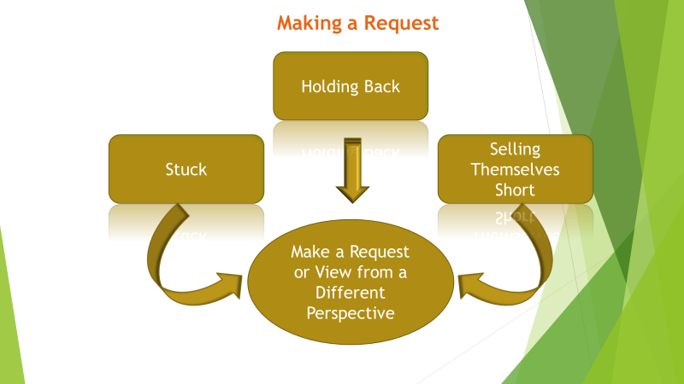 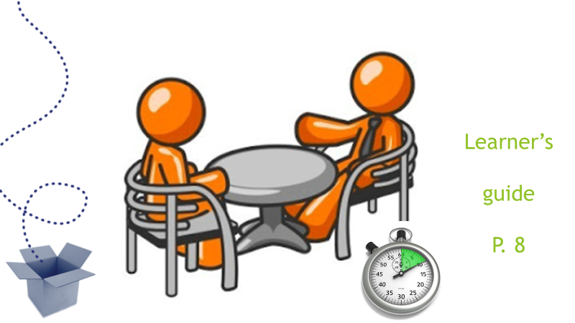

# ACTION PLANNING

Contributing Trainers: Christine Anacleto, Andrew Reid

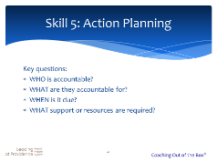Virtual COOTb Action Planning Activity

**Intention:** to add energy and sensory information to the action plan you just identified.

**Rapid response Technique.**

**Do this after completing Action Planning**

**Using Zoom, form breakout rooms of 2 people**

**Facilitator SAY: Ok everyone in break out rooms of 2, let’s add some energy to your actions.**

**This is a rapid-response activity with a high energy feel, 3 minutes per round.**

1. Form Zoom breakouts of 2p each,
2. Decide who goes first.

* **Round 1** (This is rapid-response style. Don’t over-think, just respond in 3 words max)
* Ask your partner:
  + “Think of your Action Plan.

What does success look like? 3 words max

What will it feel like? 3 words max

What will it sound like? 3 words max

When will it be done? 3 words max

* + Partners switch roles and repeat the above process.
* **Round 2**, time permitting; change to new breakouts of 2p and go again. “You will be facing a new partner. Go again, fast! “
  1. Think of your Action Plan.

What does success look like? 3 words max

What will it feel like? 3 words max

What will it sound like? 3 words max

When will it be done? 3 words max

Facilitator can do a 3rd and 4th round; time permitting. This gives diverse face time, deepens the commitment and adds energy. End with virtual high5’s!!

This also works well to close off day 1 and 2 and people appreciate something fast and active.



**Same activity for in-person classrooms:**

***Rapid Response Technique using Inner and Outer circles.* Do this after completing Action Planning.**

**Facilitator SAY: Ok everyone on your feet and let’s add some energy to your actions. (Using an open space) Bring your Action Plan to this open space.**

**This is a rapid-response activity with a high energy feel, 3 minutes per round.**

1. Form 2 circles, an inner and outer circle with same number of people in both.
2. In *inner* circle turns to look face to face with a partner in the *outer* circle.

* **Round 1** (This is rapid-response style. Don’t over think, just respond) Ask your partner:
  + “Think of your Action Plan.

What does success look like? 3 words max

What will it feel like? 3 words max

What will it sound like? 3 words max

When will it be done? 3 words max

* + Partners switch roles and repeat the above process.
* **Round 2**, “Outer circle, take one step to your left. Inner circle stay put. You will be facing a new partner. Go again, fast! “
  1. Think of your Action Plan.

What does success look like? 3 words max

What will it feel like? 3 words max

What will it sound like? 3 words max

When will it be done? 3 words max

Facilitator can do a 3rd and 4th round; time permitting, and always with outer circle moving. This gives diverse face time, deepens the commitment and adds energy. End with double high5’s!!

This also works well to close off day 1 and 2 and people appreciate something active.



## Action Planning: Getting it done

**Toolbox:**

**Full group or smaller groups:**

**Method:** Discussion,Annotation block (view, ext, select a spot, type) Chat box, paper and pen

**Action planning:** 3 types: Tangible, Discovery and learning, Evolutionary

**Goals: S**pecific **M**easurable **A**chievable **R**ealistic **T**imely

**Questions:** Who? What? When? How ?

Coaching out of the Box, Learner Guide (pg. 97-98

We were all given a task on Tuesday to review the learning materials and prepare an activity write up, on a chosen category, to be delivered today.

**Reflection:** With this task now complete, let’s reflect on what got you here.

1. What type of action was requested and by when? (refer to toolbox)
2. What steps did you take to complete task? (jot down on a piece of paper)
3. On a scale of 1-10, what was your commitment level? (post in the chat)
4. What was your biggest obstacle, if you had one? (post in the chat or write on paper)
5. What specifically did you need to do/have, to bring this goal home? (Chat or on paper)
6. Who were you accountable to? (annotated)
7. How can you make your action planning smoother next time?

# LIVE COACHING DEMO

Contributing Trainers: Paul Terry, Dave Farrell

**Live Coaching Demo Instructions**

**For Demonstrating the 5 Step Coaching Exchange**

**Purpose:** The purpose of the exercise is to illustrate for the participants what the Coaching Exchange looks like in practice, to provide a reference as you facilitate their learning of the 5 Steps.

This exercise would be one effective way to introduce Part IV of the 5/5/5 Coaching Skills Training Program™ Webinar series.

**Instructions:**

Ideally this demo is between two facilitators who know the 5 Steps of the Coaching Exchange. Alternatively, one facilitator can be the coach and can chose a participant as the coachee (prior to the webinar).

* Determine the topic and prepare the coachee to be succinct in their responses; help them understand the basic point of each Step of the coaching exchange and that the goal is to demonstrate all 5 steps.
* Set a time limit for the coaching dialogue, probably no more than 5-6 minutes. To stay within the time limit, the topic will need to be relatively “clean” or simple, where some specific actions or next steps can be determined in this amount of time.
* If possible, it would be helpful to practice the demo prior to the webinar.
* Invite the participants to observe and note the 5 Skills in use and the “flow” of the coaching demo and explain that you will conduct a short debrief at the conclusion.

**Demo Overview:**

* The coach welcomes the coachee and thanks them for their participation.
* The coach invites the coachee to **Identify** the topic and helps the coachee narrow down the goal/outcome desired for short conversation.
* To **Discover**, the coach asks the person why this particular issue/topic is important or relevant and where a good place to begin would be.
* The coach then uses *listening* and *questioning* skills to uncover the ideal state, the current gap and potential blind spots, or underlying beliefs that may be affecting progress. (Other aspects of the 5 Skills should be used by the coach as needed).
* Once the discovery process feels complete (enough) to the coachee, then the coach helps the coachee **Strategize** possible solutions or next steps, hopefully generating 2 or 3 ideas that can help the coachee get closer to their goal. These ideas should be narrowed down to at least one on which the coachee can take action.
* The coach then helps the coachee **Clear the Way** by assessing potential obstacles, identifying needed support, or other hinderances (including own hesitancy or beliefs) that might affect the ability to take the next step. Once these are identified, assessed, and addressed to the satisfaction of the coachee, the conversation moves to **Recap**.
* The coach invites the coachee to **Recap** their learning and insights from the conversation, in addition to their next steps, and confirm that the next steps will their further progress (if not completely meet) the goal outlined by the coachee at the start of the conversation. The coach should then encourage the coachee by acknowledging their progress and thank the coachee for their participation.

**Debrief:**

* The facilitator (and coachee where appropriate) then conduct a debrief of the demonstration, helping the participants clearly recognize each of the 5 Steps of the Exchange in use.
* Debrief questions might include:
  + What Skills did you notice being used?
  + What did you notice about the flow or process?
  + How was this demo (or Exchange) perhaps different from your own experience?
  + What did you learn?

## Coaching Demo Exercise

Constraint Addressed: Participants who have no previous coaching experience are often reluctant to risk a public personal display of their private thoughts, at least early in a new learning environment. They can experience the power of the coaching exchange by being the coachee, answering just four questions and noting their responses confidentially on a piece of paper.

Application: Having a taped audio or video available during online sessions of a previous coaching session works well when time and volunteers are in scarce demand. Here however is a method that uses preset questions to walk the participants through the four stages of a coaching session (In this case the ‘Excelerator Coaching Program’). You set the stage with great questions, the learning and application of coaching techniques is expedited.

* This exercise is an interactive experiential method to allow the participants to become comfortable in your learning space, safeguarding them and encouraging them to come forward for future demos as a coach or coachee.
* This exercise is very effective when you have a large audience you want to show the power of group coaching.
* This demo exercise is great in showing the power of questioning and by changing the questions you can demonstrate a number of techniques i.e. thought provoking or profound questions (a problem, matter, or point which needs to be considered).
* As a card deck this exercise can also be used by two participants to assist in the coaching exchange in breakout rooms. Great for those new to coaching.

*When Group Coaching Demo is more than a Demo*

**Participants**: writing paper and pen. **Coach**: Choose an appropriate question from list on each card. Read the card question in the order the cards are in. Use your coach voice!

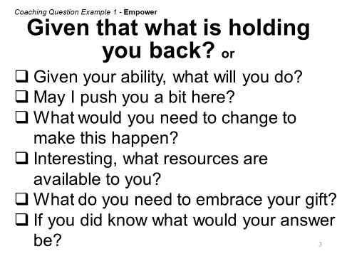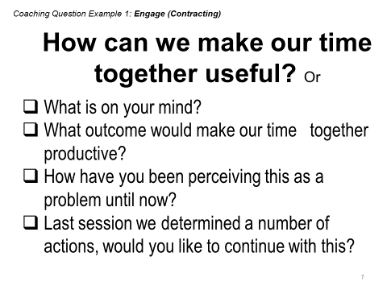**Coachee Instructions**: Please listen to the following questions (c*oach chooses first question or 🗹 alternate*) and briefly write down your first thoughts. Be open and free to write anything you are thinking or feeling as these notes are confidential to you and sharing during a coached debriefing is voluntary.

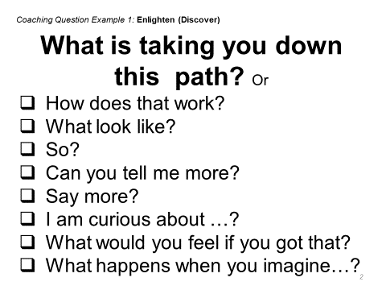

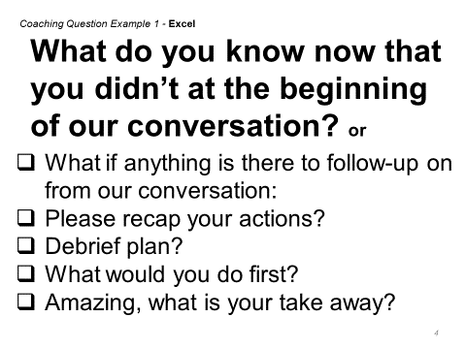**Coached Debrief**

**What?** What was in this experience for you?

**So what?** What did you learn or validate as a result?

**So when?** How can you use this learning?

Now that you know coaching is such a wonderful tool, what are you going to do next?

# GUIDING PRINCIPLES

Contributing Trainers: Valarie Waymark, Michael Lundin

## Curious exercise

Slide 1

I would like you to read the note below and with text ask CURIOUS coaching questions

* An infant left sleeping in his crib was bitten repeatedly by rats while his 16-year-old mother went to cash her welfare check.

Notes for slide

As a group let’s debrief

* Check the questions that resonate with you as curious
* What does curious me to you?
* How do we quite our bias when being curios?
* How does the framing of this potentially create bias

Slide 2

Again let’s read the note below and with text ask CURIOUS coaching questions

* Rats bit eight-month old Michael Burns five times yesterday as he napped in his crib. Burns is the latest victim of a rat epidemic plaguing inner-city neighborhoods. A public health department spokesperson explained that federal and state cutbacks forced short staffing at rat controlled housing inspection programs

Notes for slide

As a group let’s debrief

* Check the questions that resonate with you as curious
* What does curious me to you?
* How do we quite our bias when being curios?
* How does the framing of this potentially create or change your bias?

## Guiding Principle – Focus

**Group exercise:**

(Have a blank slide for annotation by participants or facilitator; or, use whiteboard)

* Think about a time you’ve had a conversation with someone who wasn’t focused on you. Using the annotation feature, type in some of the things they said or did that demonstrated a lack of focus. (Examples they might give include: glancing frequently at their mobile phone, lots of “uh-huh’s” or “Sorry…what did you just say”, shuffling papers, answering their phone mid-conversation or not turning off the ringer, allowing others to interrupt the conversation, etc.)
* How does it feel to talk to someone who is isn’t focused on you? Answer via microphone or in the chat box.
* What are some practical approaches you can take to ensure you are focused during a coaching conversation? Answer via microphone or in the chat box.

**Self-reflection:**

* Take a couple of minutes and jot down one or two of those strategies you can commit to (or create two new ones) that will help you focus when you are coaching.

# BREAKOUT ROOMS WITH DEBRIEF

Contributing Trainers: jANELLE pOTTER, sUE nIEBOER

Breakout rooms to discuss a topic, with debrief

In your breakout room, discuss the question: **What does “Coaching” mean to you**?

Select the one that the group feels is the most meaningful and report out when asked after you join the group.

Depending on the size of the group, divide them into 4-5 people in a breakout room

# WHY COACHING

Contributing Trainers: jENNIFER pOTTER, kERRY bLACK

**Go Virtual: 5/5/5 Coach**

**Lead an interactive discussion on why coaching now?**

**Week 8**

**Slide 172**

“**Your case for coaching – what will be different moving forward?**

Loop back to the start of the program. Have each person review their original case for coaching.

The purpose of this activity is to help each participant to decide and declare how coaching can/will be used by them when they return. What will be different for them moving forward as the result of what they learned and experienced?”

**Activity: Top 5 Talk Show**

Time: 20 minutes (2 minutes instruction, 8 minutes in breakout rooms, 10 minutes group presentation)

This activity answers the question:

What will be different moving forward with coaching?

Facilitator:

“We have spent the last 7 weeks looking and the power, practical application and promise of coaching for our lives, and organizations. You each set your original case for coaching when we started the course.

I am going to send you back into break out rooms to discuss the question: **What will be different moving forward with coaching?”**

Instructions:

“In your group, determine your top 5 (3, or 2 if the group is larger) points (for your organization/for yourself).

Choose a recorder, and also a speaker for your group.

List your top 5 (3 or 2) on your whiteboard, or on a power point slide to share with the other participants.

Alternately: Choose a recorder and a speaker for your group.

You will present the top 5 ideas generated by the group, in talk show format to the group.”

Place participants in breakout rooms.

At the end of their 8-minute preparation, bring groups back to share. State that if one group has already presented one of their ideas, that it should not be repeated.

**Bonus:** If you have a meeting concierge/VA or co-presenter, (or you are super good at multitasking):

Place all of the ideas into a poll format, and have the group finish this section by indicating which they feel will have the most impact for them moving forward. Create the poll in either single response or multiple response mode, it is up to you. I like multiple response format for this activity.

Purpose: Participants add to their personal list, or they may see something they may not have thought about in their group, for example.

## Why Coaching? Why Now?

**ASK:** “How many of you have worked with a professional coach?

What type of situations motivated you to work with a coach?

What kind of topics did you discuss?

Highlight that often people hire a coach when they are stuck and/or want to make a change.

**TELL:** From the explanations we just went through about the differences between coaching, mentoring and training one of the key things coaching focuses on is how to discover possibilities and move forward.

**ASK**: What are some of the benefits you have experienced with coaching in the workplace in the past?

Allow participants to respond on the chat or whiteboard.

Discuss and clarify if necessary (i.e.: How so?)

**TELL:** There are many benefits to coaching in the workplace. Coaching can greatly assist in closing the gap between current state and desire state.

Let’s dig a little deeper on the Case for Coaching in our new world.

**ASK**: So why coaching now? (Pandemic/Health Crisis, Working at Home, Virtual Teams, Social Isolation)

What are your thoughts?

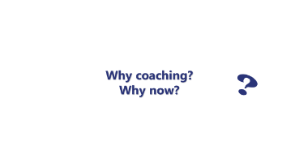

Once they give their ideas go back and discuss relevance in ”Our New World”

In our new world there is so much uncertainty for the future. People need to believe in possibility and that the future can be bright… Coaching is a wonderful tool to help people discuss their fears and blocks, clarify facts and believe in themselves that they are creative and resourceful and can create their own future that serves them.

**ASK:** What is different now with coaching? Is there more need for coaching skills now? How so?

Encourage people to raise their hand and speak to share their ideas. Or put in small break out groups to discuss.

Once they have shared discuss the next slide

**TELL:** We need to be even more agile, innovative, responsive and adaptable in our current world.

As a leader the need for the human factor and connectedness has been amplified and employees need more emotional support than ever. Mental health is a growing concern and leaders will be faced with more complex employee scenarios

In times of crisis it is critical to keep people focused on what is possible

With virtual teams we are faced with new challenges.

Let’s look at some of reasons the need for coaching skills may be more enhanced in our new world.

**Show slide:**

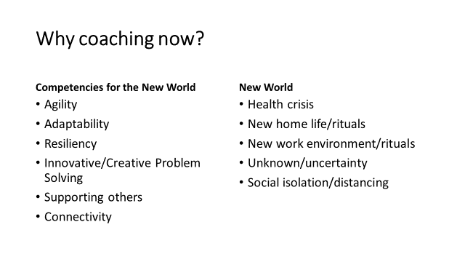

**TELL:** We have discussed these some but traditionally organizations find the following 3 potential impacts of having a coaching culture.

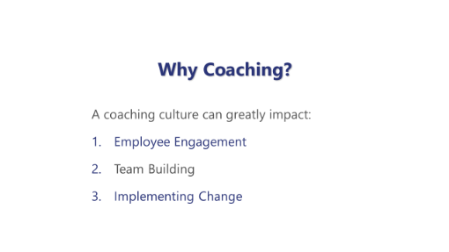

Let’s review quickly how coaching can help in these areas

**Show slides** (Review what has not already been discussed)

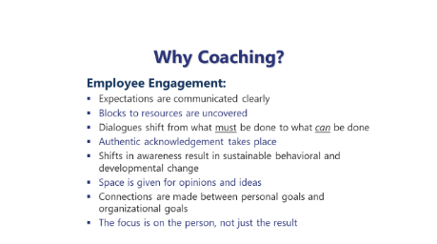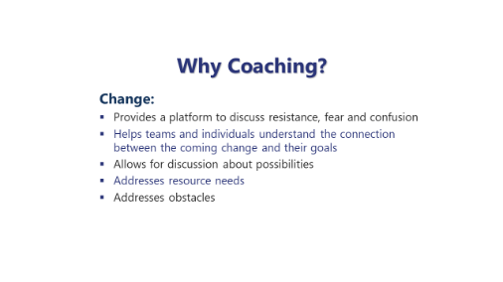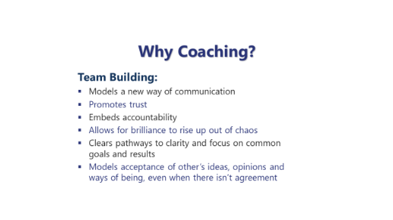

**ASK:** Why coaching now? What is your case for coaching in your current situation?

How might coaching skills help you with current challenges as a leader in our new world?

What coaching skills and practices will you focus on going forward?

**Show slide**



**TELL:** Please take a few minutes and record your answers for your case for coaching.

# USING ZOOM ANNOTATION

Contributing Trainers: cHERYL sMITH, vIVA sWANSON

Here’s my exercise for annotating

**Exercise – Questioning**

* Create a (mostly blank) PPT slide with 4 quadrants – one for each of: Clarifying, Self-Awareness, Challenging, and Action
* Provide the class with a simple scenario (e.g. ‘I (the coachee) am considering a career change and would like some coaching on this topic…)
* Ask the class to generate questions they might ask of their coachee.  (Facilitator can answer the questions if they like as well to get them to move through the process a little and encourage participants to ask more questions… or add to the scenario as they go)
* Class is to use the annotate text tool to put the questions in the quadrant.
* They could also then go through the questions afterwards and highlight using annotate tool questions which are open-ended, clean, variety (one at a time and using different colour for each).

## Annotation Exercise Guiding PRINCIPLES

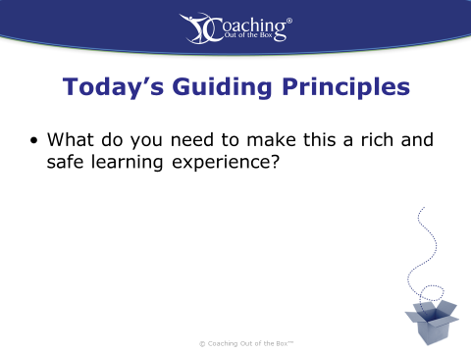

Just prior to using the slide above, introduce Zoom capacity to ANNOTATE.

Ensure the individuals are able to find the option in the drop down menu to ENABLE.

Ensure the FACILITATOR has enabled SHARE SCREEN choosing MULTIPLE PARTICIPANTS can share simultaneously.

Proceed to the slide above and ask participants to answer the question and to ANNOTATE their comments directly to the slide presented.

Where individuals struggle with the technology, REQUEST entering their comments into the CHAT BOX to EVERYONE.

Comments may be CUT & PASTED to ANNOTATE by the FACILITATOR as needed.

# DYAD COACHING AND DEBRIEF

Contributing Trainers: mArc bOWLES, bETH aNN dERKSEN

Dyads - breakout room session

COOTB, June 4, 2020

Prep

1. Determine which participants will be working together in this session. Pre-assign breakout rooms using Zoom
2. Class size – 12
   * 6 rooms of 2
3. Open Zoom meeting

Click **Breakout Rooms** in the meeting controls to access the breakout rooms you created.  
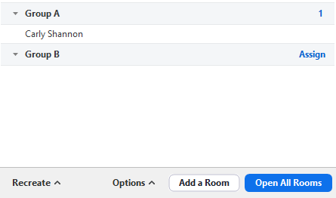

1. Prep slide deck to introduce coaching session

* Key points
  + Moving from triads with observer to only coach and coachee
  + Must be real
  + Stay curious – get focused on what really matters – right here, right now
  + Use the 5-5-5 model
* Timing – coach to be aware of time

1. Click **Open All Rooms** to start the breakout rooms.
2. Set your timer for break out room session – 10 to 12 minutes each depending on where you are in the session
3. Click **Close All Rooms** to end all breakout rooms.
4. Set up polling questions if you’re using them in this session
5. Prep debrief slide

* Key points
  + What worked well – as a coachee
  + What worked well – as a coach
  + Were there “aha” moments

## Coaching Dyad Activity – Breakout Rooms

SUMMARY

A structured way for participants to connect with partners and coach members using low and high-risk questions to explore what makes questions powerful and evocative.

TIME: 15 - 20 minutes

SET UP

* Prepare a list of [low and high risk questions](https://leadershipinspirations.com/2018/05/02/low-and-high-risk-activities/)to use during this activity.
  + **Low risk questions:** Questions that are easy for anyone to answer; allows learning coaches to provide a surface level answer. Examples:
    - If you could close your eyes and then open them and be anywhere else, where would you be?
    - If you had to rename your hometown, what would you call it?
    - Tell your life story in 60 seconds.
    - What’s one thing you like to do in your spare time?
  + **High risk questions:** Questions that require group members to provide an answer that is more personal. Examples:
    - What’s going on in your gut about leading people?
    - What if you don’t have to be good at it?
    - What is going on in week 1 that is different than week 2?

INSTRUCTIONS

* Set up the appropriate number of breakout rooms based on coaches
* Break group up into dyads (or groups of 3 if necessary)
  + You can do this any way you want, but you are trying to mix up your group
* Explain when enter in the breakout room, identify the coach and coachee - Choose a person to start.
* Coach begins by asking a low risk question to allow the pair to feel more comfortable with each other.
* After an appropriate amount of time, (5 minutes) tell the pairs to switch and allow the other person to answer the same question. Coach says “Thank you” before moving on
* Allow time for a few low-risk, surface questions to be answered and after 10minutes the group is ready to move on to the high-risk evocative powerful questions.
* Also, as an option you can switch the dyad partners in the breakouts, so that they get to know different people.
* The questions above are just examples, be creative.

VARIATION

* Speed Dating: Arrange dyads. Give each person a list of questions (low risk surface and high risk evocative) that they can choose from to ask. They will have 2-3 minutes to coach each other before being asked to move to another breakout.

SAMPLE DEBRIEFING QUESTIONS

What (eg)

* What did you notice about surface and evocative questions?
* What happened in this activity?

So What

* How is your experience different from what you expected?
* How did the experience relate to your coaching?

Now What

* How will you use this awareness in your own coaching?
* What’s one commitment each person can make?

# OTHER

Contributing Coach-Facilitators: Helen Wale, Elias Scultori, Sheeba Varghese, Lerae Gidyk

## Using resources outside or in parallel to zoom is very do-able:

External Whiteboard: <https://awwapp.com/>

Swift is the Polling by text message software company:    <https://swift.excitem.com>

## Stop wasting AIRTIME with housekeeping

Objectives and rules of engagement, welcome, even names or participates can all be done offline.

## Doing Debriefs Differently

* Before a breakout give one question they need to answer when they come back. Have people put in the chat box when they return. Example: Topic Curiosity: Charge questions is: *Return with one thing that will keep them from being curious?*
* Try giving each room a different charge question to widen the content for the debrief.
* Utilize the Poll feature for rating themselves or picking the top reason of what went well.

## Class Project

Assigned upfront. Work throughout the course and present at end of course. Your coaching case study or a team project.

## Stop sharing your screen during DEBRIEFS or key learning moments

* Stop sharing to allow the full gallery to come up on everyone’s screen.
* Have the group as primary and the powerpoint is secondary.
* Stop using the opening welcome slide and be live with the gallery and welcome each person as they arrive.

## Listen to a coaching session together

* Use a pre-recorded session. Ask the participates to listen for specific aspects and competencies in order to report it back.
* Stop asking what did you notice? Ask them to identify the specific steps and skills as they were demonstrated.

## Cut/Paste content from the chat onto your slide or whiteboard for the group to discuss.

Either using Annotation or add to a slide and share slide

## QUESTIONING Exercise

A volunteer describes a specific issue they are having presently. The group is charged to create a powerful question to ask the volunteer. Go around the room, Volunteer is not expected to response, just hear the question and move to the next person to ask the next question.

## Providing Feedback for the questions used.

Ask each person to write down a question they heard the coach use. Then go through a few of the questions and ask the group to critique the question: Open, Variety. Etc.

## Present Partner Coach

To practice and see how their own agenda gets in the way. Two or more coaches (up to 5). The coaches need to be present with each other, with the coachee and the coaching exchange. The coaches operate as one and are sharing the role, go when they want to. When one coach askes a question, it becomes really obvious when the next coach asks a completely different question or in a different direction, It speaks to how the second coach maybe influenced by their own filters, agenda and were not in the moment of the live exchange. They formulated the question in advance and didn’t listen to what the coachee is saying. The fact the conversation is organic, the observers see the power of silence and space within the conversation.

## Stemming

When there is a concept to introduce. Develop a group definition or stem about the topic. Ask for a volunteer.

When I am being a {concept} I am ________________. Then the next person builds off the last word and says When I am being a {last word} I am ________________.

Example: Topic: Eating Organic. (Ex: Being a Coach, Learning, Facilitating, etc.)

Person 1: When I am *Eating* *Organic* I am *Healthier.*

Person 2: When I am being *Healthier*  I am *Happier.*

Person 3: When I am being *Happier*  I am Calm.

Person 4: When I am being *Calm* I am Connected.

And so on …. (everyone goes at least once)

Reflect back: The group has defined Eating Organic as: Heathier, Happier, Calm, Connected ….

Have the group use the words to create a variety of definitions or statements. What is this definition telling you about the concept?

## Ask a question using the last word

Have the coachee describe a situation. When they stop speaking the coach can ONLY ask a question using the last word the coachee spoke.

**And that is the last word. Thanks to all the contributors. The ideas in this bank were shared in a public forum. It is assumed all are free of copywrite infringement and allowed for public use.**

**Re-sale and mass distribution are prohibited.**